# 1. Introduction

• Project Title: Smart Sorting: Transfer Learning for Identifying Rotten Fruits and Vegetables

• Team ID: LTVIP2025TMID40910

• Team Members:Deekshitha

# 2. Project Overview

• Purpose:  
 This project aims to help vendors, farmers, and consumers automatically detect spoiled fruits and vegetables using image classification powered by transfer learning.

• Features:

* Image upload functionality
* Instant prediction: Fresh or Rotten
* Supports categories like Apple and Tomato (Fresh/Rotten)
* HTML-based frontend
* Flask-powered backend
* TensorFlow model with Transfer Learning

# 3. Architecture

A simple pipeline architecture where the user uploads an image -> the model predicts the class (e.g., Apple - Rotten) -> and result is displayed on the UI.

# 4. Setup Instructions

• Prerequisites:  
 - Python 3.x  
 - Required packages: numpy, pandas, tensorflow, flask, etc.

• Installation:  
 - Clone/download the project  
 - Navigate to project folder  
 - Install packages using pip  
 - Run `python app.py` to launch the Flask app

# 5. Folder Structure

• Project Directory:

smart-sorting/  
 ├── app.py  
 ├── model.h5  
 ├── static/uploads/  
 └── templates/  
 ├── index.html  
 └── result.html

# 6. Running the Application

• Step 1: Open terminal and navigate to smart-sorting directory

• Step 2: Run `python app.py`

• Step 3: Open browser and go to http://127.0.0.1:5000

• Step 4: Upload a fruit or vegetable image and view prediction

# 7. API Documentation

• POST `/predict` – Handles image file upload and returns predicted label

• GET `/` – Loads upload form (index.html)

# 8. Authentication

• Not required. All users can access the prediction page without login.

# 9. User Interface

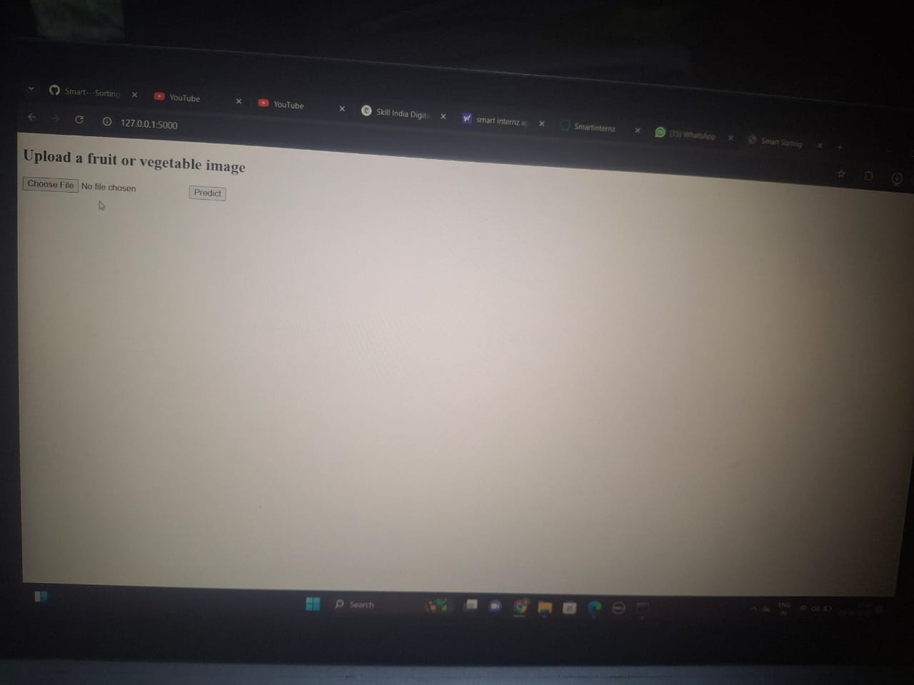

• index.html – Upload form for image

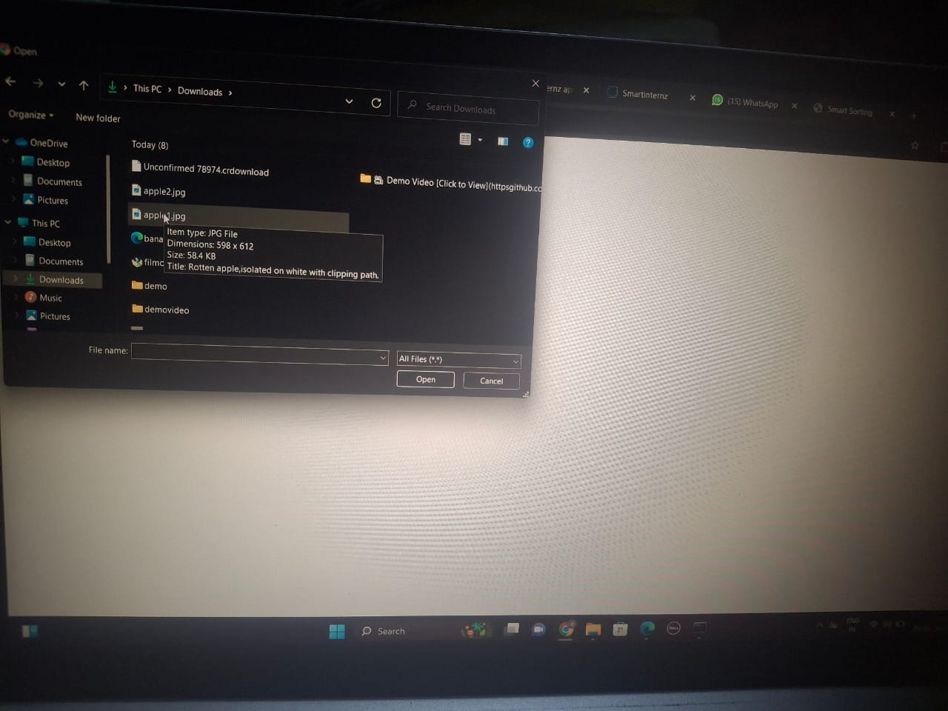

• result.html – Displays prediction result and uploaded image

# 10. Testing

• Manual testing using fresh and rotten fruit images  
• Observed correct predictions for apple rotten/fresh classification

# 11. Screenshots or Demo

• Uploading apple image (image1)



• Prediction screen showing "Apple - Rotten" (image3)

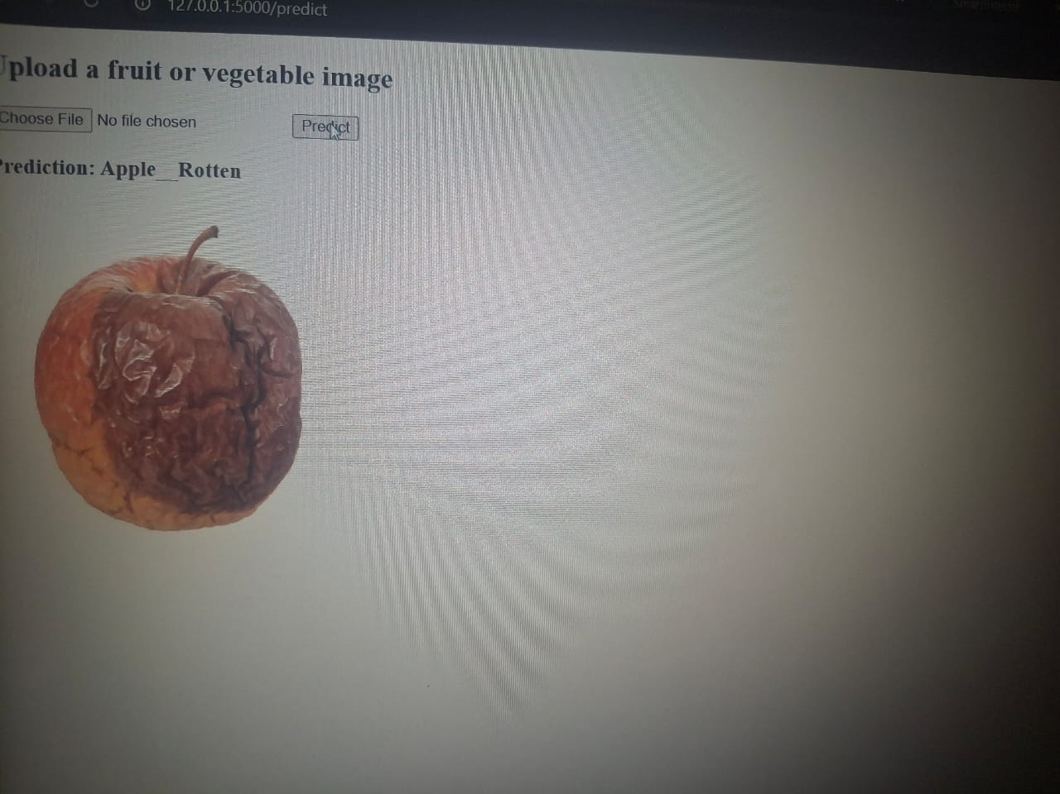

# 12. Known Issues

• No camera integration

• Limited categories (only Apple and Tomato, fresh/rotten)

• Prediction may vary based on lighting/image quality

# 13. Future Enhancements

* Add camera capture support
* Expand dataset with more fruits and vegetables
* Display confidence score
* Deploy on cloud
* Add voice or multilingual feedback